Use Case Diagram

[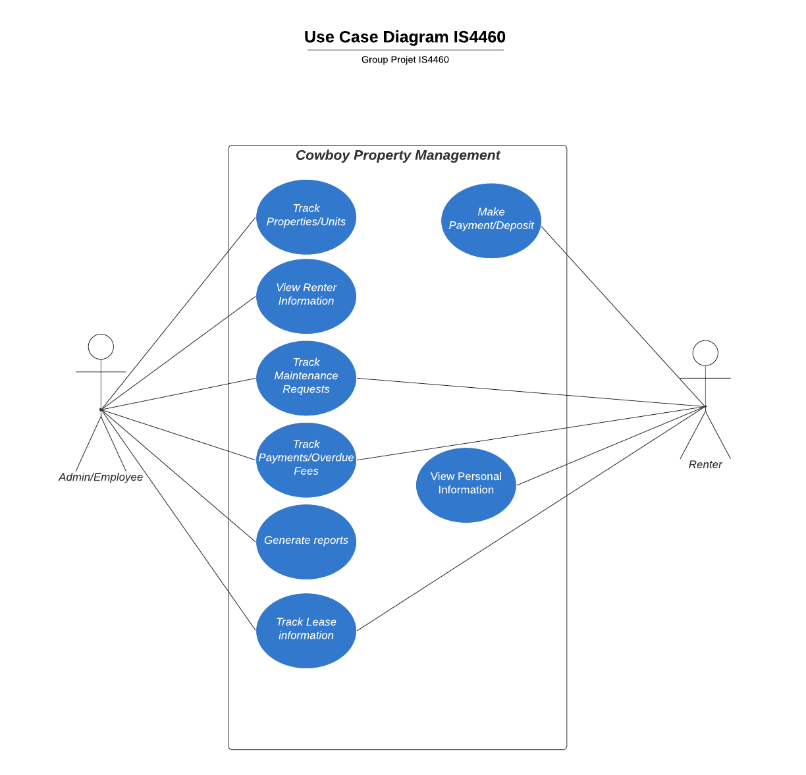](https://lucid.app/documents/edit/a81129b3-b228-4560-aef8-ba0d1113ebb5/0?callback=close&name=docs&callback_type=back&v=185&s=612)

Use Case Narratives

|  |
| --- |
| **Use Case: Generate reports** |
| **Objective:** Generate various reports including: maintenance, overdue renters/amounts, and the monthly rental collection for each property |
| **Business Event:** Generate various reports including: maintenance, overdue renters/amounts, and the monthly rental collection for each property |
| **Primary Actor(s):**  Admin, Employee |
| **Secondary Actor(s):** None |
| **Pre-Condition:** User(s) must be logged into the system.  User clicks ‘Generate Reports’ and the respective report they want to generate |
| **Post-Condition:** User is forwarded to the generated report page |
| **Failure Outcomes:** User is in the generate report page, report fails to generate.  User is shown an error message ‘Error Generating Report’. |

|  |  |  |
| --- | --- | --- |
| **Flow Events** | **Actor** | **System** |
| 1 | User in the home page (home.php).  User clicks on the Generate Reports page (generate_reports.php). | Generate New Report page is shown |
| 2 | Users select reports they’d like to generate. |  |
| 3 | User submits their selection. | Connect to the database.  Report details are generated.  Forward user to the generated-report.php page. |
| 4 | User sees the generated_report.php page. |  |

|  |
| --- |
| **Use Case: Make deposit/payments/overdue fees** |
| **Objective:** Make a payment for fees or a deposit |
| **Business Event:** Make a payment for fees or a deposit |
| **Primary Actor(s):**  Renter |
| **Secondary Actor(s):** None |
| **Pre-Condition:** User must be logged into the system.  User clicks on the ‘Make a Payment’ link in their home page |
| **Post-Condition:** User is forwarded to the Payment page |
| **Failure Outcomes:** User is in the payment page.  Card is invalid and doesn’t process, displays message ‘Invalid Card Number, please try again.’ |

|  |  |  |
| --- | --- | --- |
| **Flow Events** | **Actor** | **System** |
| 1 | User in the home page (home.php).  User clicks on the Make A Payment page (make_payment.php). | Make a payment page is shown |
| 2 | Users select if they want to make a deposit/payment or pay an overdue fee |  |
| 3 | User submits their selection. | Page is shown where they can enter card information for payment |
| 4 | User sees the payment confirmation page. | Receipt is displayed of payment that was just made |

|  |
| --- |
| **Use Case: User can view personal information** |
| **Objective:** View personal information for correct account |
| **Business Event:** View personal information for correct account |
| **Primary Actor(s):**  Renter |
| **Secondary Actor(s):** None |
| **Pre-Condition:** User must be logged into the system.  User clicks on view personal information. |
| **Post-Condition:** User is forwarded to the personal information page with correct information displayed. |
| **Failure Outcomes:** Personal information cannot be updated, displays error message ‘Changes not saved, please try again’. |

|  |  |  |
| --- | --- | --- |
| **Flow Events** | **Actor** | **System** |
| 1 | User in the home page (home.php).  User clicks on the View personal information (personal_info.php). | Personal information page is shown |
| 2 | Users can see all their information displayed |  |
| 3 | User can edit information if needed | Connect to the database.  New updates are saved. |
| 4 | User can save any changes | Displays update person information page |

|  |
| --- |
| **Use Case: User can view leases and account information** |
| **Objective:** View leases and account information for correct account |
| **Business Event:** View leases and account information for correct account |
| **Primary Actor(s):** Renter |
| **Secondary Actor(s):** None |
| **Pre-Condition:** User must be logged into the system.  User clicks on view leases and account information. |
| **Post-Condition:** User is forwarded to the leases and account information page with correct information displayed. |
| **Failure Outcomes:** Account information cannot update, displays error message ‘Changes not saved, please try again’. |

|  |  |  |
| --- | --- | --- |
| **Flow Events** | **Actor** | **System** |
| 1 | User in the home page (home.php).  User clicks on the leases and account information page. | Leases and Account Information page is displayed. |
| 2 | User can view lease information, but cannot edit it. They can also view their account information, and they are able to make changes to that if needed. |  |
| 3 | User can edit information if needed | Connect to the database.  New updates are saved. |
| 4 | User can save any changes | Displays updated person information page |

|  |
| --- |
| **Use Case: View properties and their property units (rented and available)** |
| **Objective:** Display information about available and leased properties and the units |
| **Business Event:** Display information about available and leased properties and the units |
| **Primary Actor(s):**  Admin, Employee |
| **Secondary Actor(s):** None |
| **Pre-Condition:** User(s) must be logged into the system.  User clicks ‘View Properties & Units’ page |
| **Post-Condition:** User is forwarded to the the properties page |
| **Failure Outcomes:** Properties cannot be updated, displays error message ‘Error Saving Changes, please try again’. |

|  |  |  |
| --- | --- | --- |
| **Flow Events** | **Actor** | **System** |
| 1 | User in the home page (home.php).  User clicks on the properties and property units. | Properties and Property Units page is shown |
| 2 | User can view property information and the units in the property, both rented and available. They are able to make changes and update properties. |  |
| 3 | User can edit information if needed | Connect to the database.  New updates are saved. |
| 4 | User can save any changes | Displays updated properties page |

|  |
| --- |
| **Use Case: View leases and payments/overdue fees** |
| **Objective:** Display information about leases and payments as well as renter’s with fees that are overdue |
| **Business Event:** Display information about leases and payments as well as renter’s with fees that are overdue |
| **Primary Actor(s):**  Admin, Employee |
| **Secondary Actor(s):** None |
| **Pre-Condition:** User(s) must be logged into the system.  User clicks ‘Leases and Payments/Overdue fees” |
| **Post-Condition:** User is forwarded to the the Leases and Payments/Fees page |
| **Failure Outcomes:** Reminder message couldn’t send, displays error message ‘Reminder not sent, please try again’. |

|  |  |  |
| --- | --- | --- |
| **Flow Events** | **Actor** | **System** |
| 1 | User in the home page (home.php).  User clicks on the Leases and Payments/Fees page | Leases and Payments/Fees page is shown |
| 2 | Users can view information about renter’s leases and any payments or fees that are needed. |  |
| 3 | They can send a prompt to the renter’s to remind them to make their payments and overdue fees. | Connect to the database.  Reminder message sent to corresponding renter’s portal. |
| 4 | User receives a confirmation of any reminder message that was sent | After confirmation, Leases and Payments/Fees page is shown |

|  |
| --- |
| **Use Case: View maintenance requests** |
| **Objective:** Display information about maintenance requests that have been made and where. This ensures that all properties are well maintained and operational. |
| **Business Event:** Display information about maintenance requests that have been made and where. This ensures that all properties are well maintained and operational. |
| **Primary Actor(s):**  Admin, Employee |
| **Secondary Actor(s):** None |
| **Pre-Condition:** User(s) must be logged into the system.  User clicks ‘Maintenance Requests’ |
| **Post-Condition:** User is forwarded to the the Maintenance Requests page |
| **Failure Outcomes:** Error with scheduling a time, displays error message ‘Unable to schedule maintenance, please try again’. |

|  |  |  |
| --- | --- | --- |
| **Flow Events** | **Actor** | **System** |
| 1 | User in the home page (home.php).  User clicks on Maintenance Requests page | Maintenance Requests page  is shown |
| 2 | Users can view information about renter’s requests for maintenance. They can view what type of maintenance was requested and for what properties. |  |
| 3 | Users can act on the maintenance requests and schedule times to work on the request. | Connect to the database.  Alert renter that a maintenance time has been scheduled and when. |
| 4 | User receives a confirmation of any reminder message that was sent. | After confirmation, the main Maintenance Request page is shown. |

|  |
| --- |
| **Use Case: View renters and prospective renters** |
| **Objective:** Display information about current renters and potential renters |
| **Business Event:** Display information about current renters and potential renters |
| **Primary Actor(s):**  Admin, Employee |
| **Secondary Actor(s):** None |
| **Pre-Condition:** User(s) must be logged into the system.  User clicks ‘Renter & Prospective Renters’ |
| **Post-Condition:** User is forwarded to the the Renter & Prospective Renters page |
| **Failure Outcomes:** |

|  |  |  |
| --- | --- | --- |
| **Flow Events** | **Actor** | **System** |
| 1 | User in the home page (home.php).  User clicks on Renter & Prospective Renters page | Renter & Prospective Renters page is shown |
| 2 | Users can view information about the current renters and the potential applicants. |  |